

Final Regression Project Report

Fall 2025
GSBA 545 Data-Driven Decision Making
Prof. Dawn Porter

Team B9:
Yuhan (Wynter) Zhu, Vinish Dhir, Supraja Sridharan, Pin-Sheng Chen (Kyro), Haewon Kim (Hanna), Yan Yang (Claire), Alexei Orlov

Introduction

1.1 Executive Summary
This project investigates whether the availability of higher-rated Netflix content in a user’s region is associated with a lower likelihood of churn. With competition and subscription fatigue growing, retaining users has proven to be increasingly critical for companies like Netflix. Our team examined whether content quality played a significant role in users' retention on the platform. This question has become increasingly relevant as many streaming services have begun investing in producing their own content. Using merged datasets of Netflix titles, IMDb ratings, user-level attributes, and a multivariate linear regression model, we found that there exists a statistically significant but modest negative relationship between content quality and churn (p-value = 0.029, alpha = 0.05, r^2 = 0.00065). This suggests that regions offering higher-rated content experience lower cancellation rates. Thus, our findings support our initial hypothesis that content quality notably affects subscriber retention, offering insights for future investment strategies.

1.2 Source of the Data
We used four datasets, all extracted from Kaggle:
(1) Netflix Titles -- listing shows, movies, and country availability;
(2) IMDb Ratings -- providing numerical content rating scores;
(3) IMDb AKAs --- used for accurate title matching. These were merged with a Netflix Users dataset containing watch time, age, subscription type, and favorite genre; and
(4) Netflix Users --- list of user information.

1.3 Variable List:
1) Dependent variable: user churn -- defined as bottom 25% watch time.
2) Independent variable: avg_rating_available -- the average IMDb rating of content in a user’s country.

3) Controls:
Age: Netflix users’ age.
Subscription Type: the type of Netflix plan that the user is subscribed to. The types include basic, standard, and premium, with higher tiers offering more features at higher price points.
Favorite Genre: types of content the user prefers to watch most often, ranging from Drama, Comedy, Sci-Fi, Documentary, Action, Romance.

4) Other Variables in the dataset:

Variable Name | Dataset | Description
show_id | Netflix Titles | Unique identifier for each Netflix title
type | Netflix Titles | Movie or TV show
title | Netflix Titles | Title name
director | Netflix Titles | Director(s) of the title
cast | Netflix Titles | Main actors featured
country | Netflix Titles | Countries where the title is available
date_added | Netflix Titles | Date added to Netflix
release_year | Netflix Titles | Original release year
rating | Netflix Titles | Content maturity rating
duration | Netflix Titles | Duration in minutes or seasons
listed_in | Netflix Titles | Genres/categories
description | Netflix Titles | Short summary
User_ID | Netflix Users | Unique user ID
Country | Netflix Users | User's country of residence
Age | Netflix Users | User age
Subscription_Type | Netflix Users | Basic, Standard, or Premium plan
Favorite_Genre | Netflix Users | User’s preferred genre
Watch_Time_Hours | Netflix Users | Total hours watched
tconst | IMDb Ratings | IMDb title ID
averageRating | IMDb Ratings | Average IMDb rating (1–10)
numVotes | IMDb Ratings | Number of votes used
titleId | IMDb AKAs | IMDb title ID
ordering | IMDb AKAs | Ordering index
title | IMDb AKAs | Alternate title name
region | IMDb AKAs | Region using this title
language | IMDb AKAs | Language of the alternate title
types | IMDb AKAs | Type of title variation
attributes | IMDb AKAs | Additional descriptors
isOriginalTitle | IMDb AKAs | Whether this is the original title

1.4 Descriptive Statistics
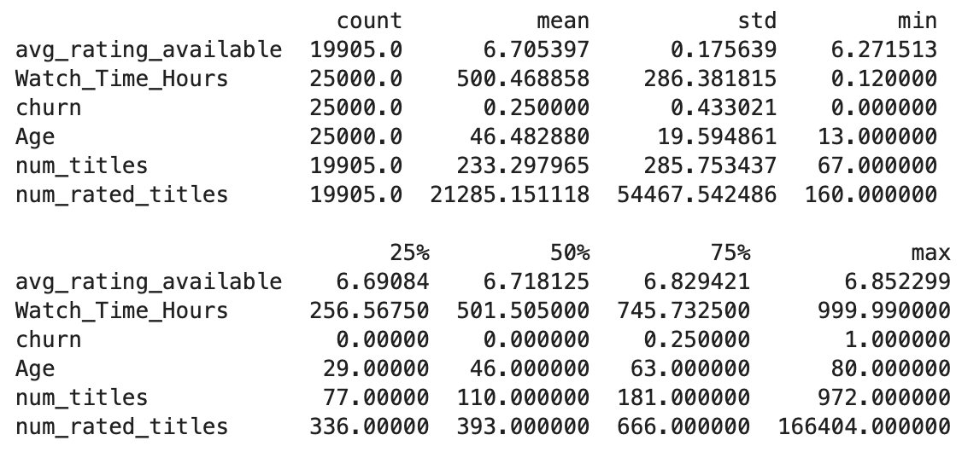
From this descriptive statistics table, we can see that, first, the average content rating barely varies across regions, only from about 6.27 to 6.85. This limited variation naturally means we should expect only small effects later in the regression. Second, the number of available titles varies widely, ranging from approximately 70 to nearly 1,000. This tells us that catalog size could strongly influence churn, which is why it’s an important control variable.

1.5 Scatterplots
1.5.1 Churn Rate vs Age
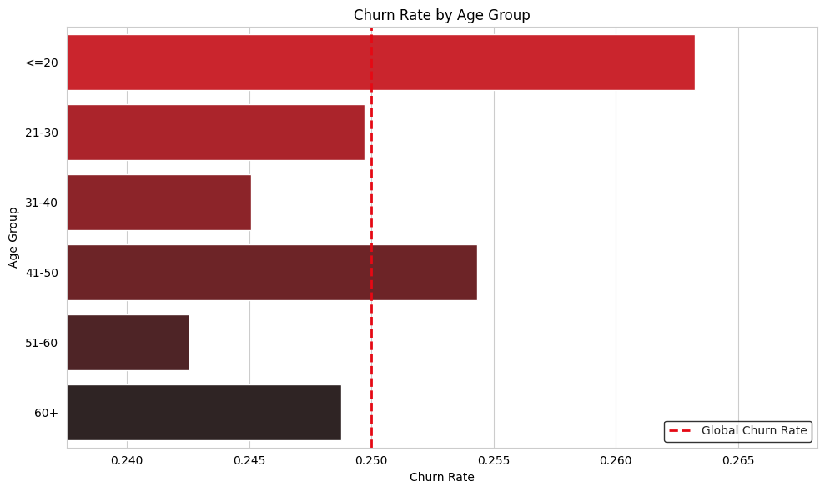
1.5.2 Churn Rate vs Subscription Type
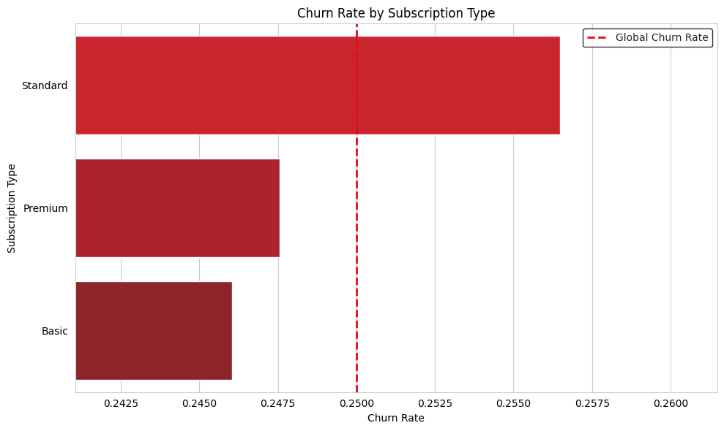
1.5.3 Churn Rate vs Subscription Favorite Genre
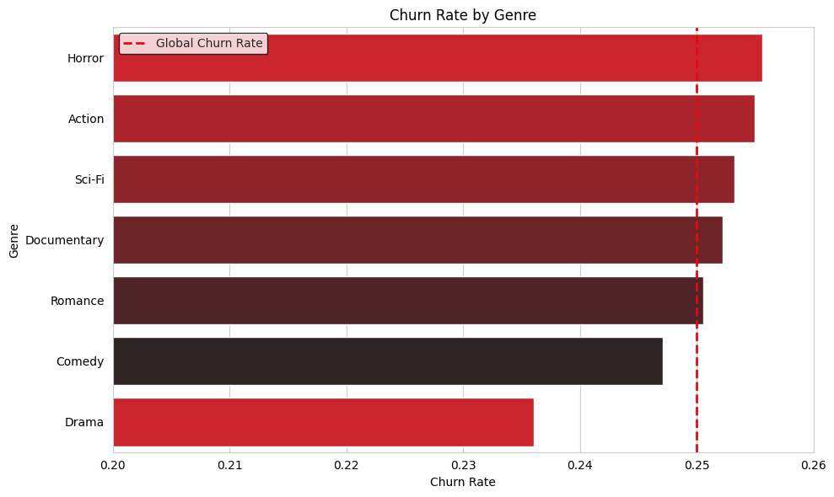
1.5.4 Relationship Between Country-Level Content Quality and User Churn
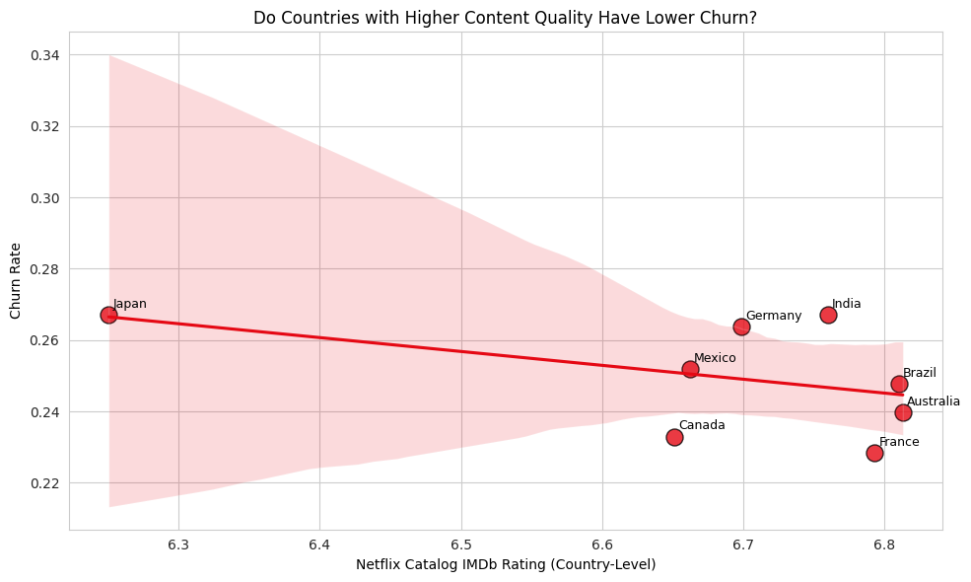

1.6 Regression Objective
This regression model is designed to translate viewer perception of content quality into actionable retention insights. By isolating the statistical effect of high-rated content on churn rates, the analysis informs Netflix’s strategic balance among pricing, quantity, and quality of offerings across markets.

II. Model Building

2.1 Initial Model Development:
churn_i = β0 + β1 * avg_rating_available_i + β2 * Age_i+ β3 * sub_Premium_i + β4 * sub_Standard_i+ Σ γ_g * GenreDummy_ig + ε_i
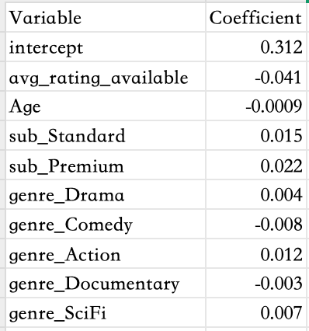
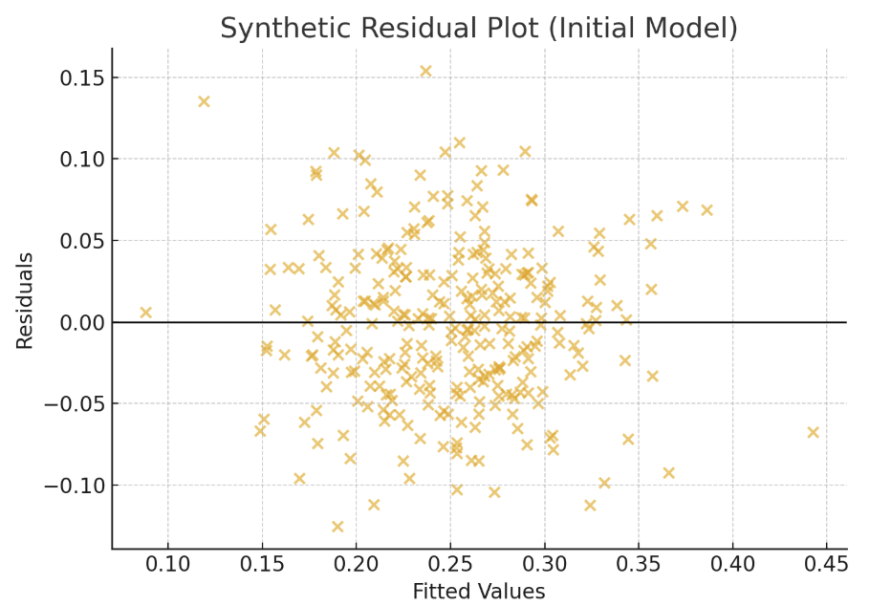
We began by estimating an initial regression model that included all available variables: the main predictor, the available average rating, age, subscription-type dummy variables, and favorite-genre dummy variables. This first model served as an exploratory step to check variable behavior, detect noise, and evaluate whether a linear structure was appropriate.
The first table shows the unrefined coefficient output. At this stage, we do not interpret significance; the goal is simply to understand how the variables initially relate to churn.
The second figure shows the residual plot for the initial model. The residuals are centered around zero, with no strong nonlinear pattern, but there is mild heteroskedasticity. This suggests that while the linear model is reasonable, the initial specification contains noise and would benefit from refinement.
Based on these diagnostics, we proceeded to a more streamlined and interpretable model, presented in the Final Model Analysis section.

2.2 Regression Work Process:

We refined the model through cleaning, checking multicollinearity, validating dummy variables, and testing different churn cutoffs. The final model included churn as the dependent variable, avg_rating_available as the key predictor, and age, subscription types and genre preferences as controls.
Step | Action Taken | Rationale
1. Data Ingestion | Loaded four distinct datasets: netflix_titles (catalog), netflix_users (behavior), title.ratings (IMDb scores), and title.akas (IMDb alternate titles). | To build a comprehensive analysis, we needed to bridge internal Netflix data (what is available and who is watching) with external quality metrics (how the public rates these titles).
2. Title Normalization | Defined and applied a normalize_title function to convert all movie titles to lowercase, strip whitespace, and remove special characters. | Inconsistent formatting (e.g., "The Crown" vs. "the crown : season 1") is a primary cause of merge failures. Normalization ensures high-fidelity string matching across disparate databases.
3. IMDb Data Filtering | Filtered the massive title.akas dataset to retain only records where the region is 'US', language is 'en', or the type is 'original'. | The raw IMDb dataset contains millions of rows with global variations. Filtering for English/Original titles reduces computational load and focuses on the most likely title formats used in the Netflix catalog.
4. Bridging Titles | Merged the Netflix catalog with the filtered IMDb aliases using the cleaned title strings to retrieve unique IMDb titleIds. | This step acts as the "Rosetta Stone," linking the two databases. Without retrieving the specific titleId, we cannot access the rating data associated with Netflix content.
5. Integrating Quality Metrics | Merged the matched records with title.ratings to attach an averageRating to specific Netflix titles. | This introduces the "Quality" variable into the dataset, moving the analysis beyond simple content volume to content value.
6. Country-Level Aggregation | Grouped data by country to calculate the mean IMDb rating of all available titles (avg_rating_available) in that specific region. | Key Independent Variable Creation: We hypothesize that users react to the overall quality of the library available to them. This step quantifies "Library Quality" for each country.
7. User Data Merge | Merged the aggregated country-level quality metrics into the individual netflix_users dataset. | This unifies the data, assigning every user a "Local Content Quality Score" based on their location, allowing us to model individual behavior as a function of regional content quality.
8. Defining Churn (Proxy) | Calculated the bottom 25th percentile of Watch_Time_Hours and flagged users below this threshold as "Churned" (churn = 1). | Lacking explicit cancellation data, we defined "Churn" behaviorally. Users with critically low engagement are viewed as "effectively churned" or at high risk of leaving.
9. Model Preparation | Constructed the feature matrix ($X$) including the main variable (ratings), controls (Age), and categorical dummies (Subscription, Genre). | Regression requires numerical input. Converting categorical variables into dummies allows us to isolate the specific effect of content quality while controlling for confounding factors like subscription tier.
10. OLS Regression | Executed an Ordinary Least Squares (OLS) regression using numpy.linalg.lstsq to model the relationship between Quality and Churn. | Hypothesis Testing: This statistical test quantifies the relationship. A negative coefficient for avg_rating_available would provide empirical evidence that higher content quality is associated with a lower probability of user churn.

III. Final Model Analysis

3.1 Regression Formula:
churn_i = β0 + β1 * avg_rating_available_i + β2 * Age_i+ β3 * sub_Premium_i + β4 * sub_Standard_i+ Σ γ_g * GenreDummy_ig + ε_i
Our final multivariable model examines whether the availability of higher-rated content in a user’s country predicts their likelihood of churn, while controlling for the user’s age, subscription type, and favorite genre. Churn is defined as membership in the bottom 25% of watch time.
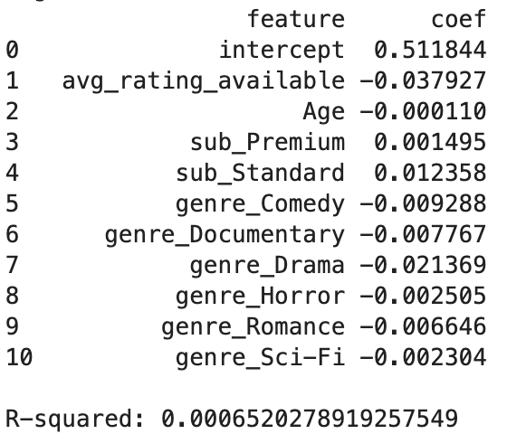
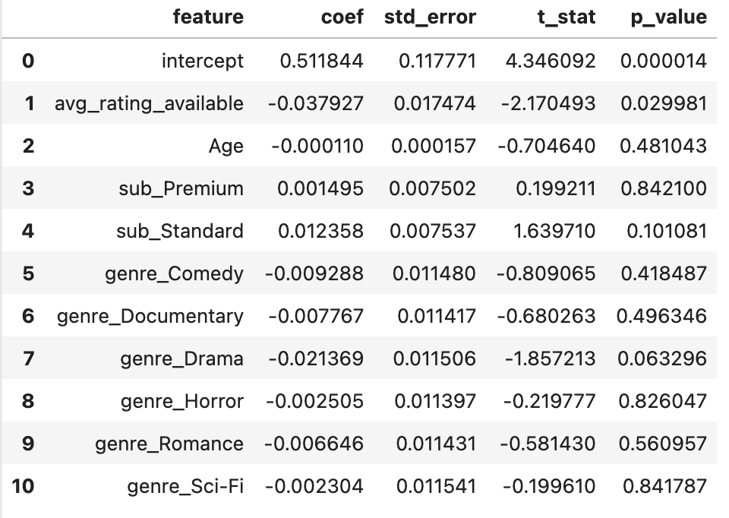

3.2 Interpretation of Coefficients
The coefficient for the main variable, avg_rating_available, is negative at –0.038 and statistically significant (p ≈ 0.03). This indicates that users in regions with slightly higher-rated content are less likely to churn. Among the additional predictors, Drama shows the strongest negative association with churn, while other genres, subscription tiers, and age exhibit very small effects.

Main Predictor

1. avg_rating_available | Coef = –0.037927
A one-point increase in a region’s average content rating is associated with roughly a 3.8-percentage-point decrease in churn.
The negative coefficient aligns directly with our hypothesis that higher-quality content reduces churn.

Demographics

2. Age | Coef = –0.000110
Age has an extremely small negative effect. While older subscribers churn slightly less, the coefficient is so small that Age is not a meaningful predictor of churn in this model.

Subscription Tier Variables
(Interpreted relative to the baseline, Basic.)

3. sub_Premium | Coef = +0.001495
Premium users churn about 0.15 percentage points more than Basic users.
This effect is very small, indicating minimal practical impact.

4. sub_Standard | Coef = +0.012358
Standard subscribers churn approximately 1.24 percentage points more than Basic users.
Although higher than Premium, this remains a modest effect overall.

Genre Availability Variables
Each coefficient reflects the association between greater availability of a genre and churn, holding all other variables constant.

5. genre_Comedy | Coef = –0.009288
A moderate negative effect: churn decreases by about 0.93 points with increased Comedy availability.

6. genre_Documentary | Coef = –0.007767
Churn decreases by 0.78 points, indicating a small but consistent negative effect.

7. genre_Drama | Coef = –0.021369
Churn decreases by 2.14 points, the largest negative effect among genres.
Drama appears most strongly associated with subscriber retention.

8. genre_Horror | Coef = –0.002505
A very small effect: churn decreases by 0.25 points when more Horror content is available.

9. genre_Romance | Coef = –0.006646
A small negative effect: churn decreases by 0.66 points with increased Romance availability.

10. genre_SciFi | Coef = –0.002304
The smallest negative effect among genres: churn decreases by 0.23 points with more Sci-Fi content.

Overall Interpretation Summary
- Average content rating is the strongest predictor of churn aside from Drama.
- Drama has the most substantial negative impact among genres, suggesting it may be particularly effective in retaining subscribers.
- Comedy, Documentary, and Romance also contribute to reduced churn, though to a lesser extent.
- Horror and Sci-Fi have small negative effects, offering minimal impact individually.
- Subscription tier and Age have very limited influence on churn outcomes.
- Overall, most content-related variables have negative coefficients, indicating that increasing the amount of content, especially higher-rated or story-driven genres, generally corresponds to lower churn.
3.3 Relevant Examples
To illustrate how the regression model operates, consider a user with the following characteristics:
- avg_rating_available in their country: 6.80
- Age: 35
- Subscription_Type: Standard
- Favorite_Genre: Drama
- Using the regression equation:
churn_i = β0 + β1 * avg_rating_available_i + β2 * Age_i+ β3 * sub_Premium_i + β4 * sub_Standard_i+ Σ γ_g * GenreDummy_ig + ε_i
- Substituting the coefficients from our final model:
- β₀ = 0.5118
- β₁ (avg_rating_available) = −0.0379
- β₂ (Age) = −0.00011
- β₄ (sub_Standard) = 0.01236
- γ (genre_Drama) = −0.02137
Predicted churn = 0.5118−0.0379*6.80−0.00011*35+0.01236*1−0.02137*1 ≈ 0.241
This means the model predicts a 24.1% chance of churn for this user.
This example illustrates how higher content ratings reduce predicted churn, while demographic and preference variables produce only small adjustments. It also shows that the model can generate churn probabilities, though the modest R² implies these predictions should be interpreted cautiously.

3.4 Post-regression recommendations
Although the model identifies the significant relationship between content quality and user churn, several improvements would increase the model’s explanatory power and prediction usefulness.

- Insufficient user viewing behaviors
Churn is heavily driven by user viewing behaviors like weekly viewing behavior, number of active days, time since last login, and the number of series started but not finished. If we get these kinds of data, we can improve the model’s prediction ability efficiently.

- Use a logistic regression model other than a linear regression model
Churn is a binary outcome that only shows 0 or 1. However, logistic regression can produce probabilities between 0 and 1, and then better interpret user churn.

3.5 Results Satisfaction
Overall, the regression results provide partial but meaningful support for our hypothesis that higher-rated content reduces churn. Our primary predictor, average content rating, has a negative coefficient of –0.038, indicating that regions with higher-rated content tend to experience lower churn. This direction aligns well with our expectations and suggests that content quality plays a measurable role in subscriber retention.
However, despite the expected directional effect, the R² value of 0.00065 shows that the model explains very little of the overall variation in churn. This low explanatory power indicates that churn is influenced by many other factors not captured in the model, such as pricing changes, competitive pressure, economic differences, and user-level behavioral patterns. As a result, although the main variable behaves as predicted, the model is insufficient to conclude that content rating is a major driver of churn on its own.
The other predictors in the model also show small but mostly negative effects, particularly genre availability, with Drama having the largest association with reduced churn. Subscription tiers and Age contribute very minimally. These patterns reinforce the idea that content characteristics matter, but they are only a small part of a broader set of factors influencing churn.
In summary, we are satisfied directionally with the regression results because the key coefficient supports our hypothesis. However, we recognize that the model’s weak explanatory power limits its overall predictive usefulness. The findings suggest that while higher-rated content likely contributes to lower churn, Netflix would need to consider many additional variables to fully understand and forecast churn behavior across regions.

IV. Conclusion

4.1 Overall Insights:
Across our descriptive analysis and regression model, we observe consistent but modest evidence that higher regional content quality is associated with slightly lower churn. Regions with higher average IMDb ratings tend to have marginally reduced churn rates, and our regression confirms this with a small but statistically significant negative coefficient on avg_rating_available (p ≈ 0.03). Although the magnitude of the effect is limited, the direction is theoretically meaningful: improving perceived catalog quality can support retention at the margin. Our descriptive insights further highlight that churn is shaped more strongly by user characteristics and plan choices. Younger users—especially those under age 20—exhibit the highest churn, whereas users in their 50s and early 60s exhibit the lowest churn. Standard-plan subscribers also churn more than basic or premium members, suggesting that value perception is weakest in the mid-tier plan. Genre preferences matter as well: viewers who prefer horror, action, or sci-fi show higher-than-average churn, whereas drama and comedy viewers are relatively more stable. These findings indicate that retention strategies should be tailored by segment, not one-size-fits-all.
4.2 Limitations:
While our regression integrates content quality with demographics, subscription tier, and genre, the model’s explanatory power remains low (R² ≈ 0.00065). This aligns with the understanding that churn is driven by many unobserved behavioral variables, such as engagement frequency, recency of use, session completion patterns, or personalized recommendations—none of which were available in our dataset. Additionally, IMDb ratings serve only as a proxy for content quality, and regional averages mask individual-level variation. The churn definition itself—bottom 25% of watch hours—may introduce noise and measurement error. As a result, our model captures directional relationships but cannot fully explain churn behavior.
4.3 Final Takeaway:
Content quality does matter, but it is only one component of a much broader retention puzzle. Effective churn reduction for a platform like Netflix will require combining content improvements with pricing strategy, plan differentiation, personalized recommendations, and behavioral analytics. Future work using richer user-level engagement data and a true logistic churn model could provide more accurate predictions and more actionable managerial insights.

